**On-Page Optimization**

**Recommend a call-to-action (CTA) if applicable.**

Ensure every product page features a clear and compelling call-to-action (CTA).

Examples include:

* "Buy Now"
* "Explore More Titan Watches"
* "Get Free Shipping on Orders Above $100"

Position CTAs prominently near key areas such as:

* Product descriptions
* Pricing sections

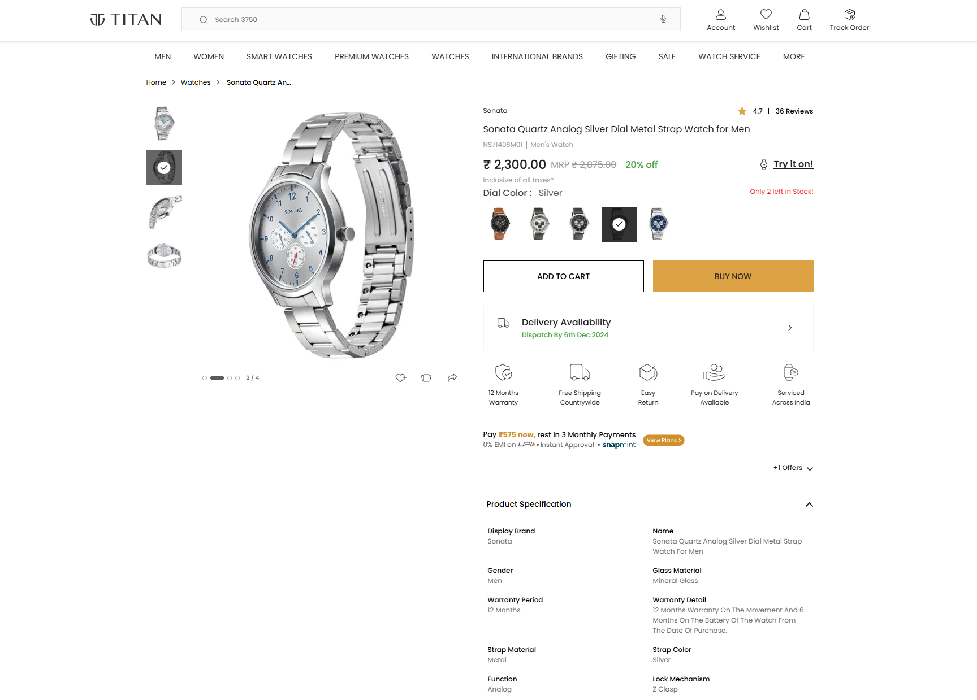

**Suggest internal linking opportunities and anchor text usage.**

1. **Related Products**: Add a link like *"Explore our Titan Smartwatches for Men"* that directs users to the Smartwatches category page.
2. **Product Guides**: Include a link such as *"Learn how to choose the perfect luxury watch"* leading to a blog or guide on selecting the ideal watch.
3. **FAQ Section**: Provide a link like *"Find answers to common questions about Titan watches"* that takes users to the FAQ page.
4. **Offers Page**: Highlight your deals with a link like *"Check out our latest deals on Titan watches"* pointing to the Discounts or Offers page.
5. **After-Sales Services**: Build trust by adding a link like *"Discover Titan's repair and warranty services"* leading to the Support or Warranty page.

**Keyword Research and Strategy**

**Short-Tail Keywords**

* Titan watches - >100 volume in 1 day
* Titan watches india - >100 volume in 5 days
* Women’s titan watches - <100 volume
* Smartwatches
* Premium Watches
* Men’s Watches

**Long-Tail Keywords**

* Titan watch price 1000 to 1500 - <100 volume
* Titan watches for womens with price list – <100 volume
* Titan watches for men with price - 100 volume
* Top smartwatches featuring fitness tracking
* Stylish leather-strap watches for women
* Buy Analog watches for Men at the Best Price

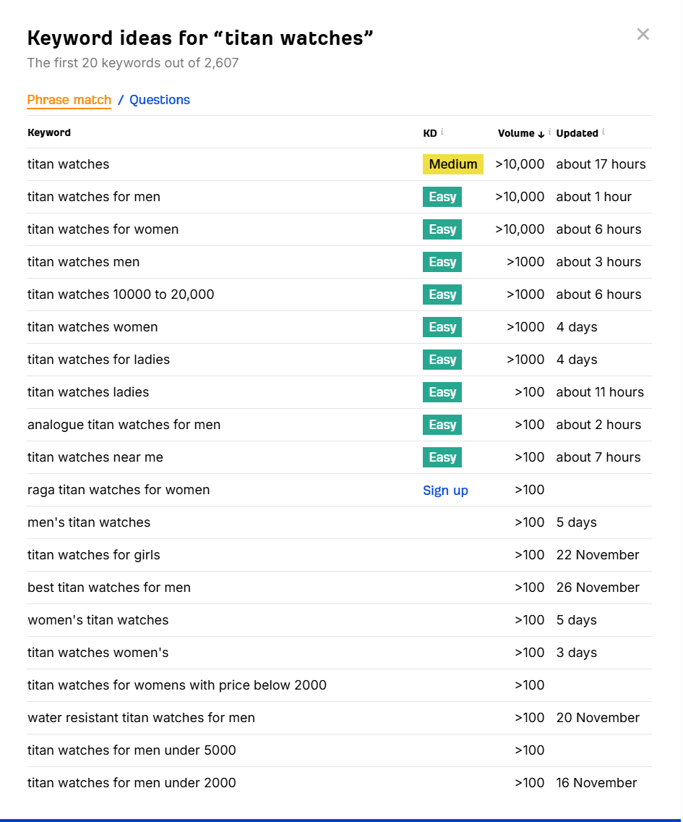

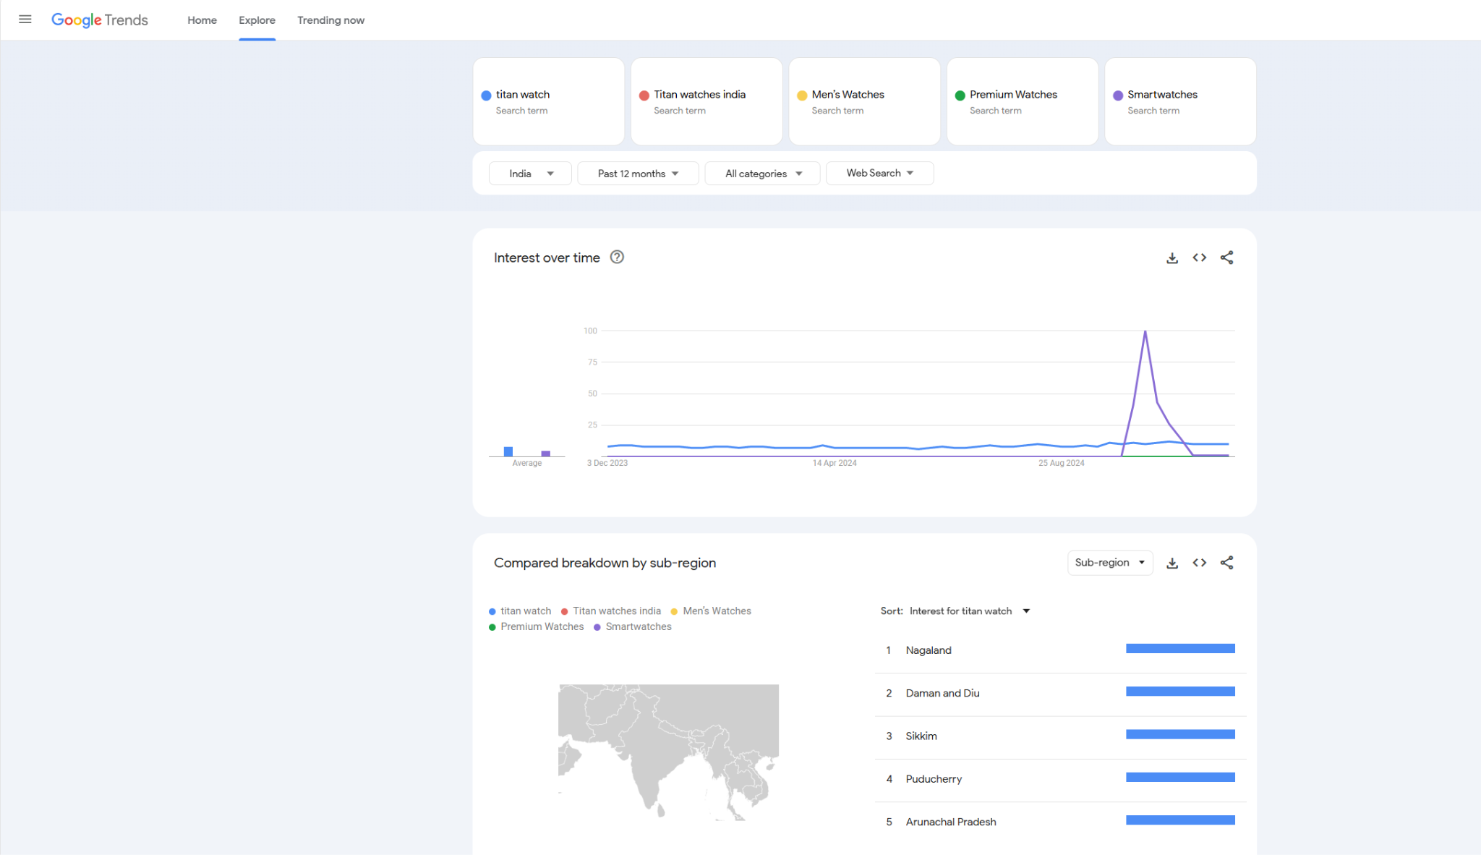

Keyword overview

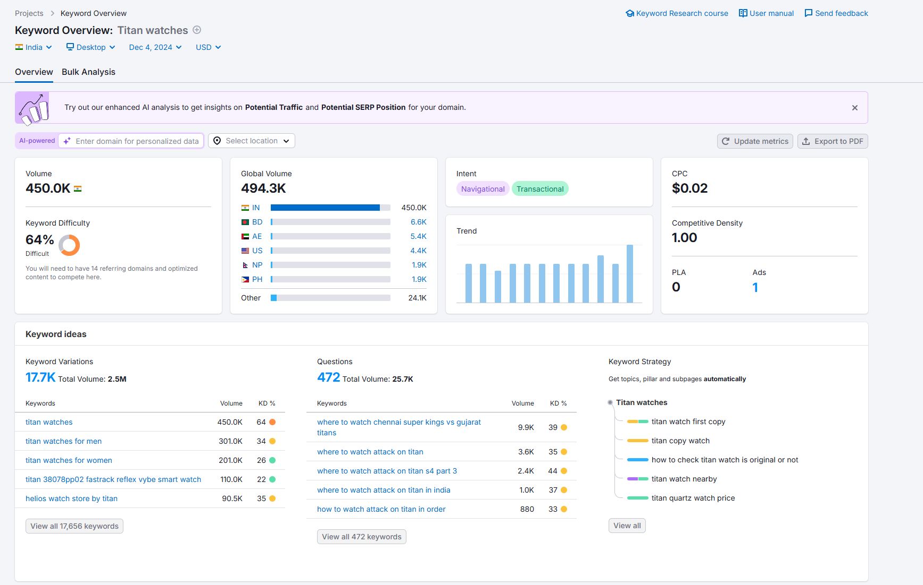

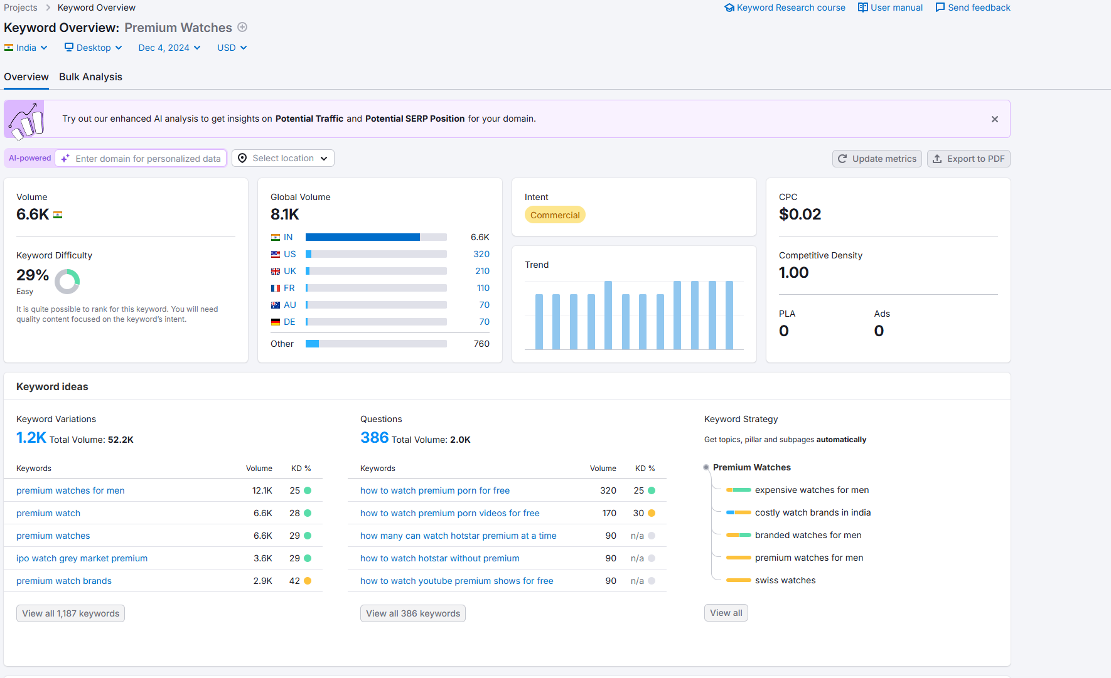

Domain Analytics

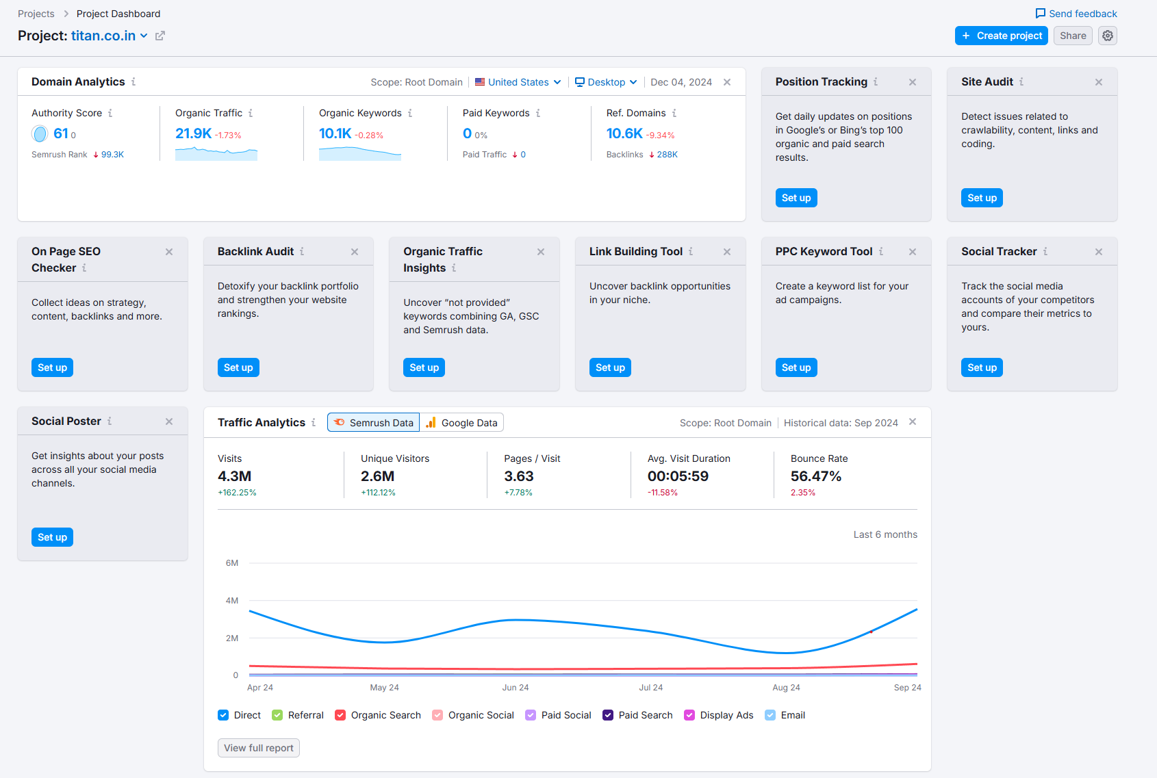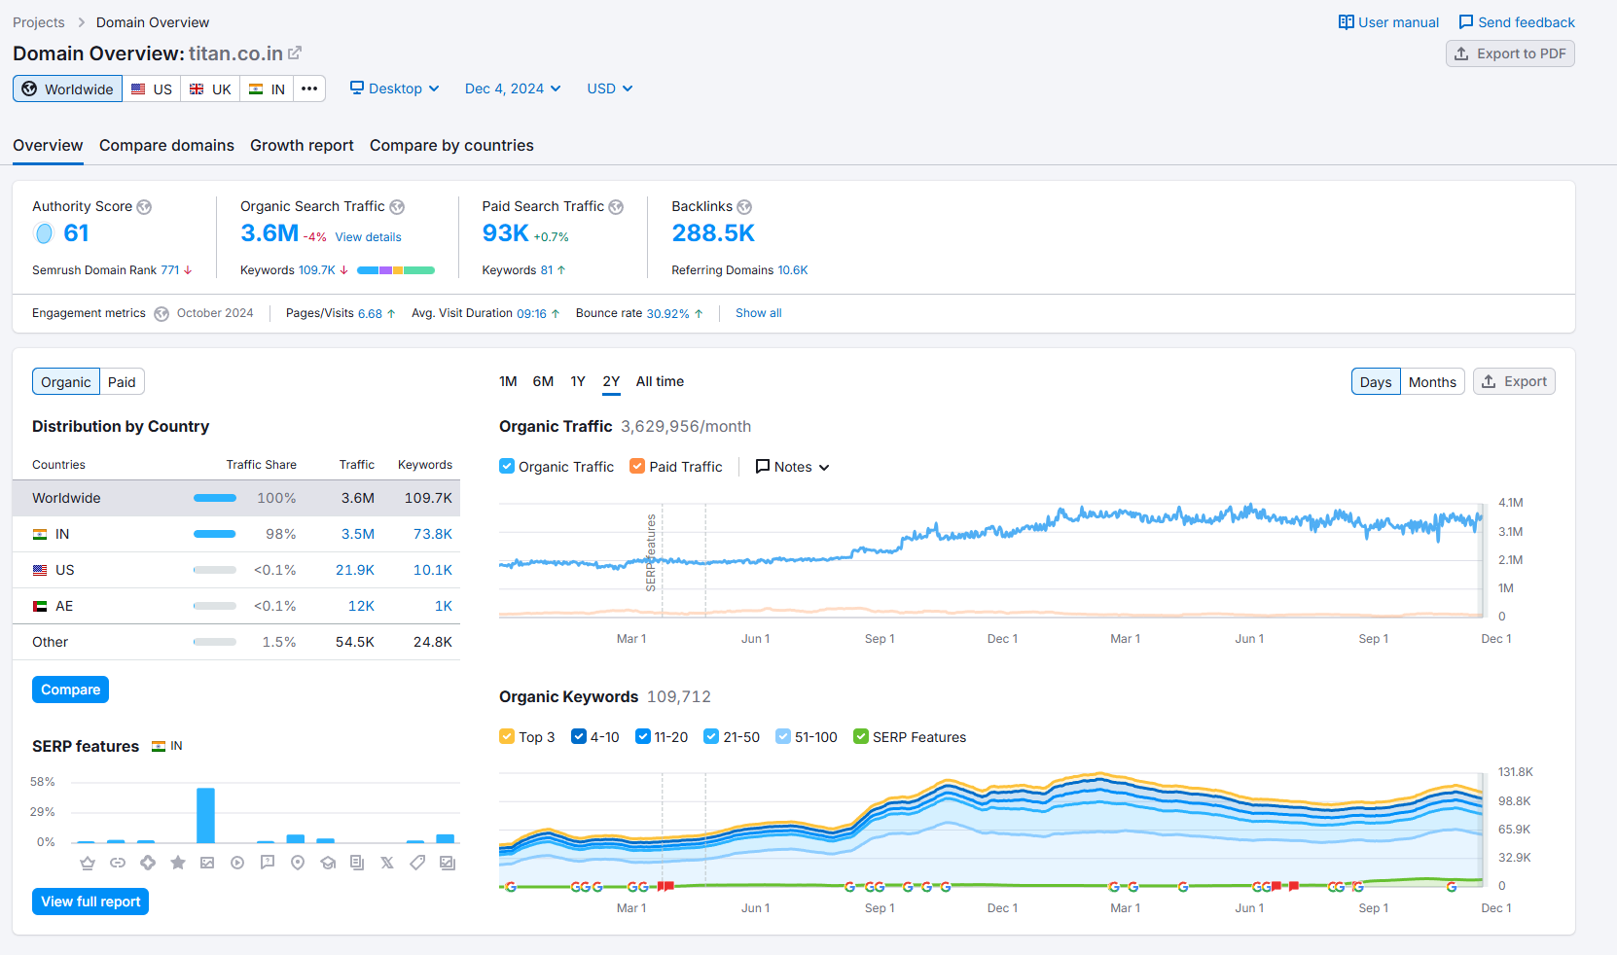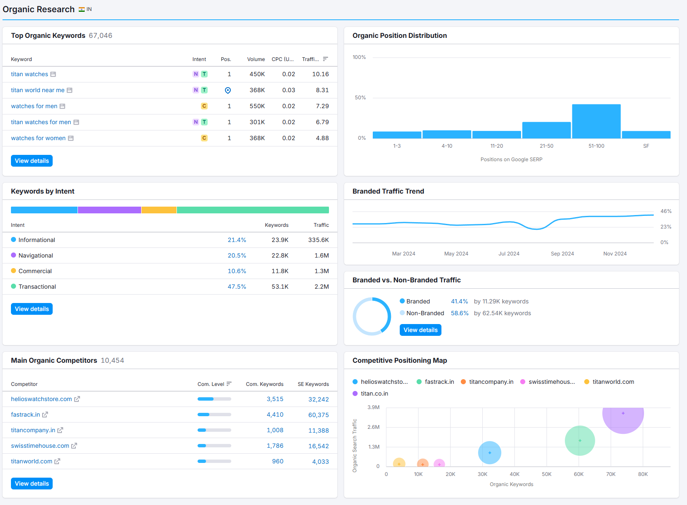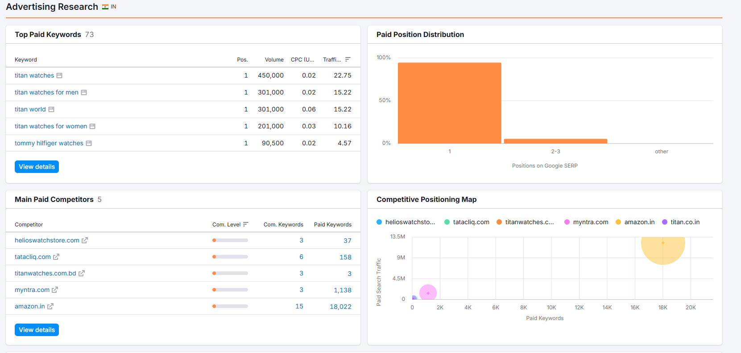

Traffic Analytics

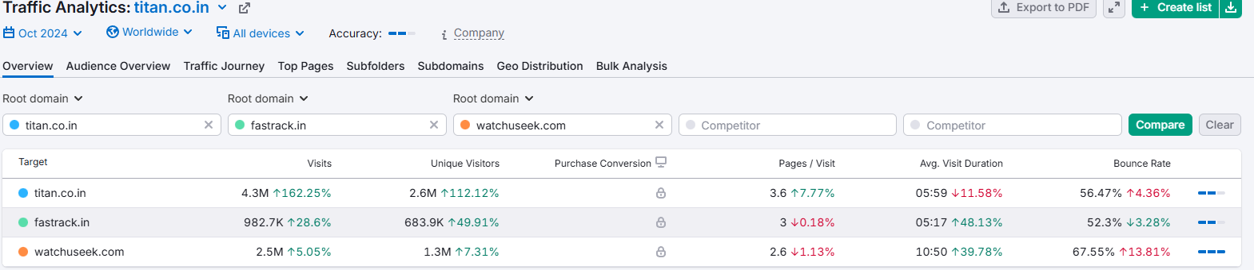

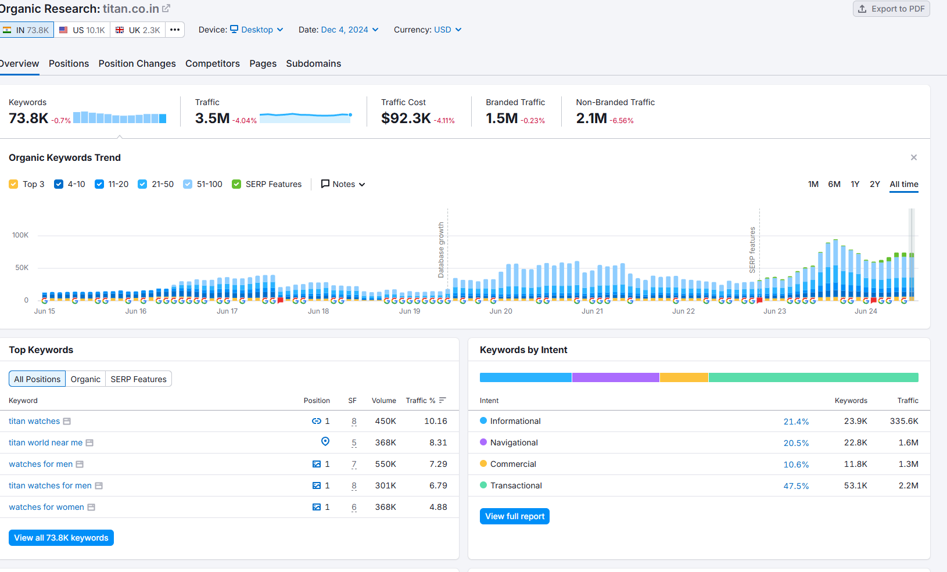

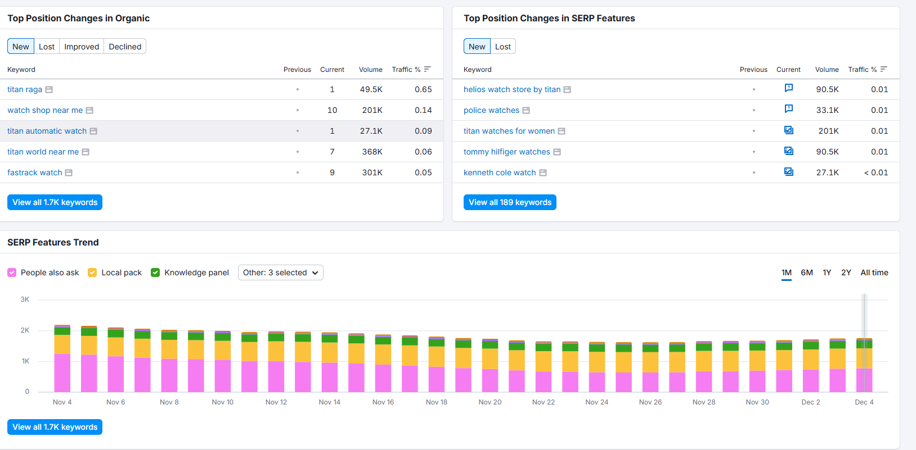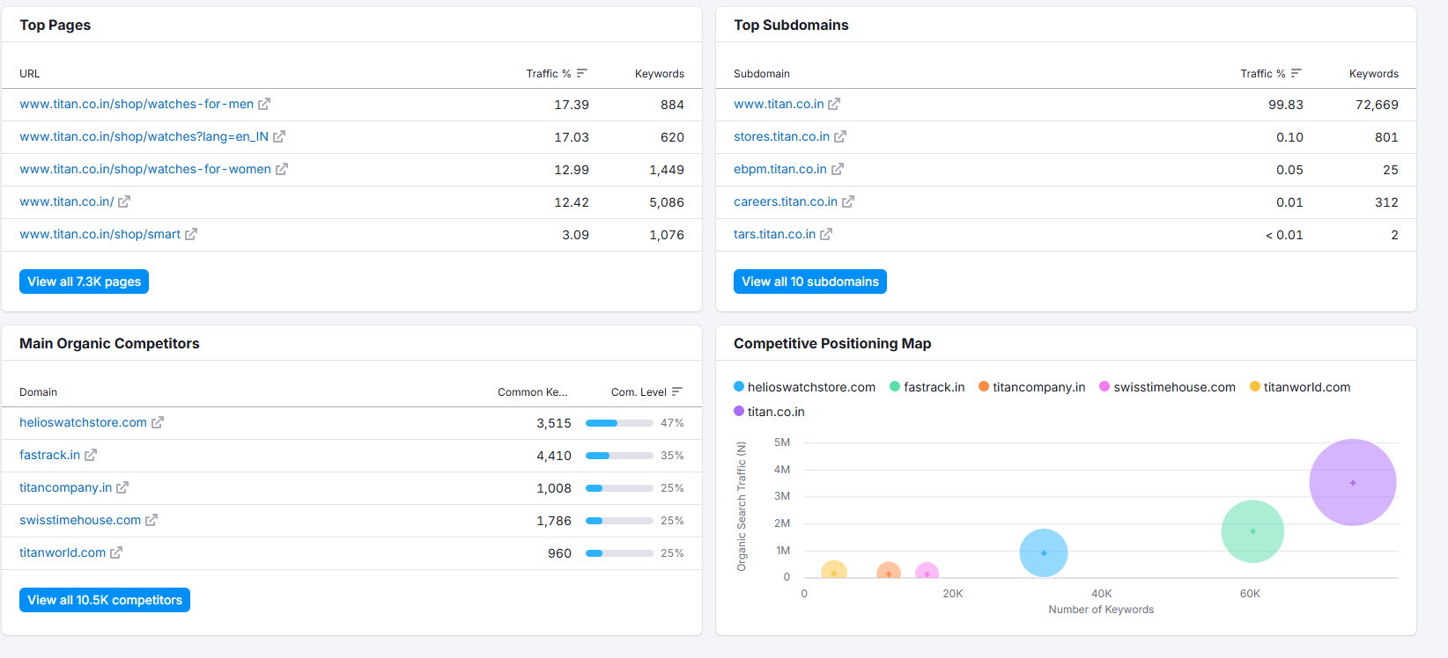

Keyword Gap

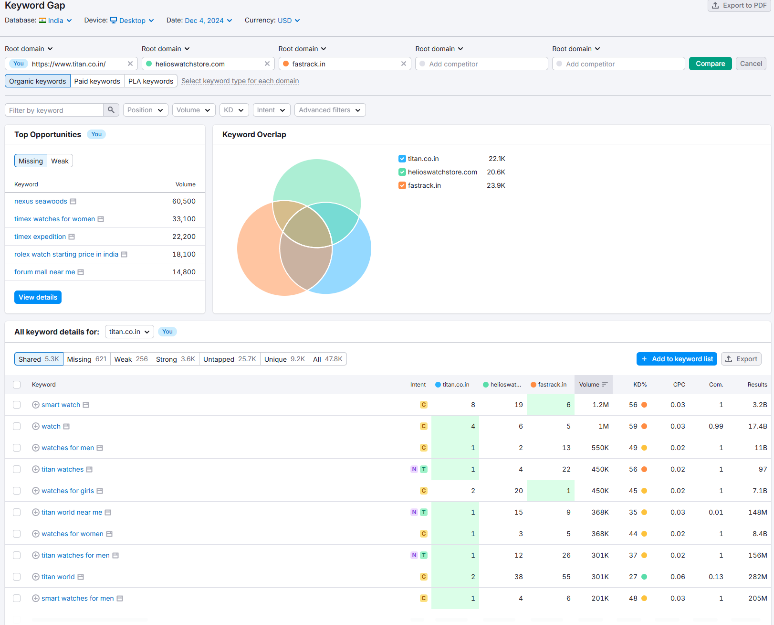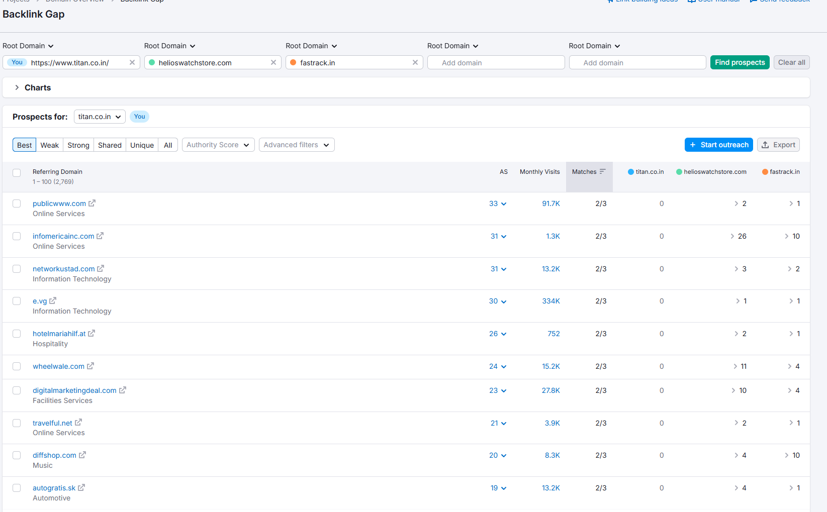

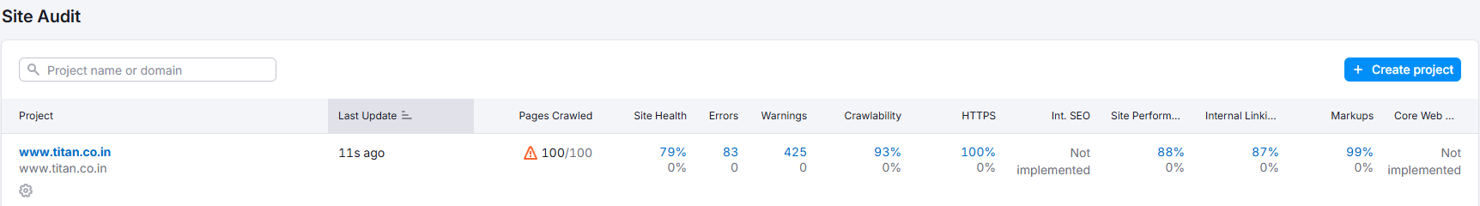

Backlinks

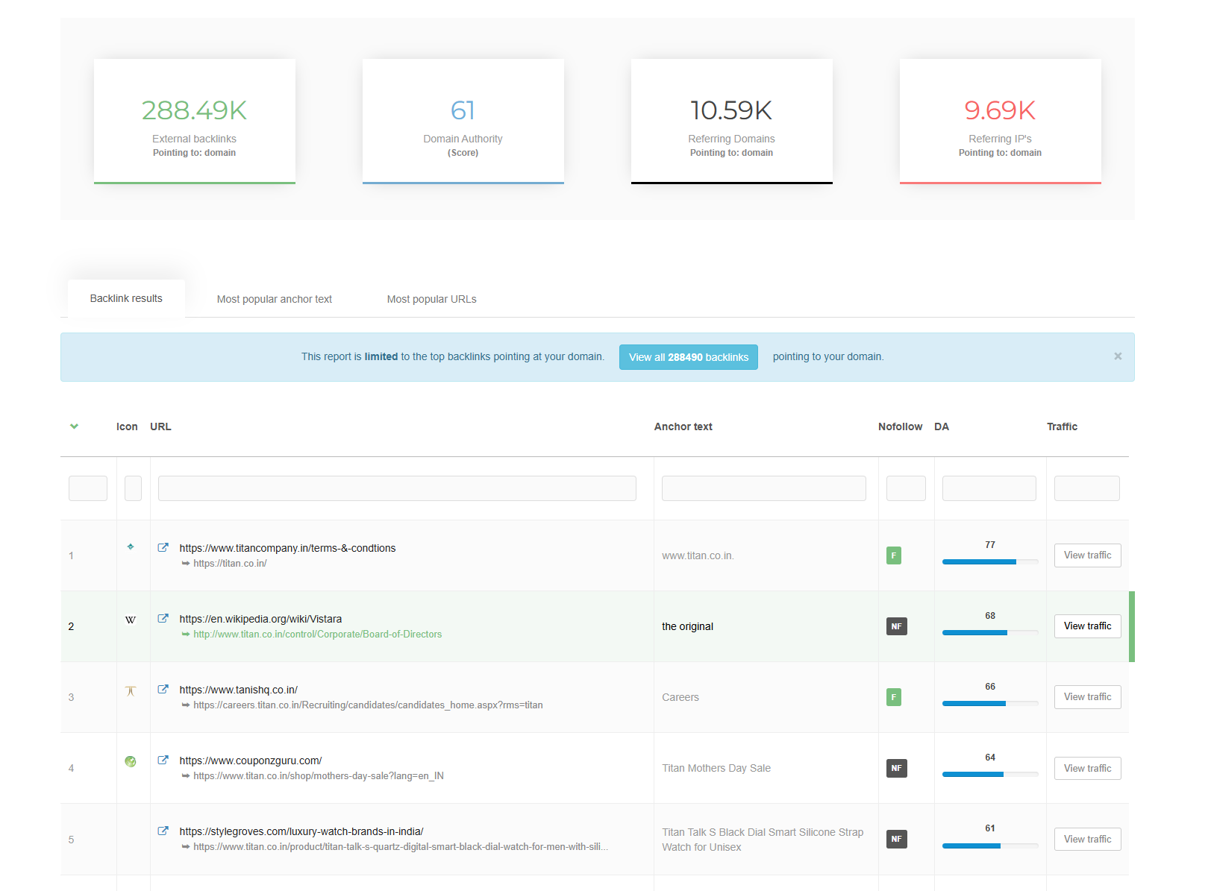

FAQ

